Dianne X

summary
I am a qualified Teacher Aide with 3 years experience in a school environment and a further 8 years experience working in the child care sector. I have a proven ability to communicate well with teachers and contribute to a well organised, positive learning environment. I am seeking a challenging primary school role where I can assist children achieve their potential. I am compassionate and excel at connecting with all children including those with additional needs and disabilities.

Experience

Dec 20XX–Jan 20XX
Teacher Aide • Sydney State School
- Support to Prep & Yr1 classes
- Specialist support to students with Autism, ADHD, vision impairment and behaviour disorders
- Experience with reading, literacy and numeracy support programs
- Preparation of classroom materials

Feb 20XX–Dec 20XX
Educator • Apple Day Care
- Supervision of children indoors and outdoors
- Creating and implementing educational program including Kindergarten curriculum programs
- Maintaining a clean, hygienic education space and ensuring all WHS procedures are followed.

education

Adapt Education
- Dec 2021: CHC30221 Certificate III in School Based Education Support
- Jan 2022: HLTAID012 Provide First Aid in an education and care setting

SKILLS & knowledge
- Applying behaviour management strategies
- Use of Educationnet to access school procedures and submit forms
- Accomplished pianist and passion for music

References
John Smith – Supervising Teacher, Sydney State School, Jsmith@sydneyss.edu.au; 0414 414 414
Marie White – Director, Apple Daycare.
Marie@appledaycare.com.au; 0400 777 888
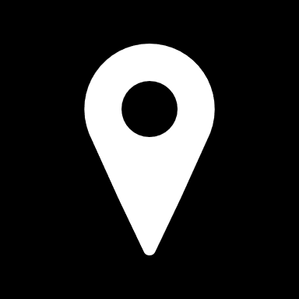 | Brisbane QLD 4000
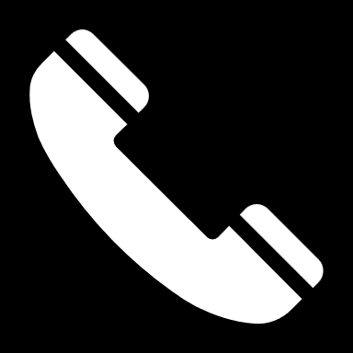 | 0400 111 222
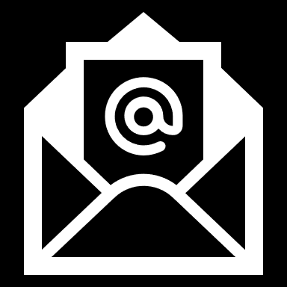 | Dianne@gmail.com
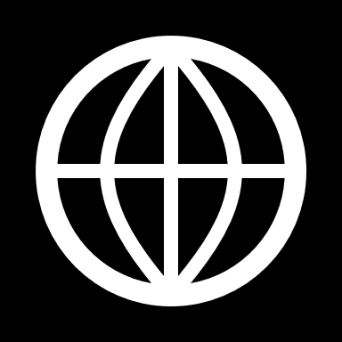 | www.dianne.com.au

